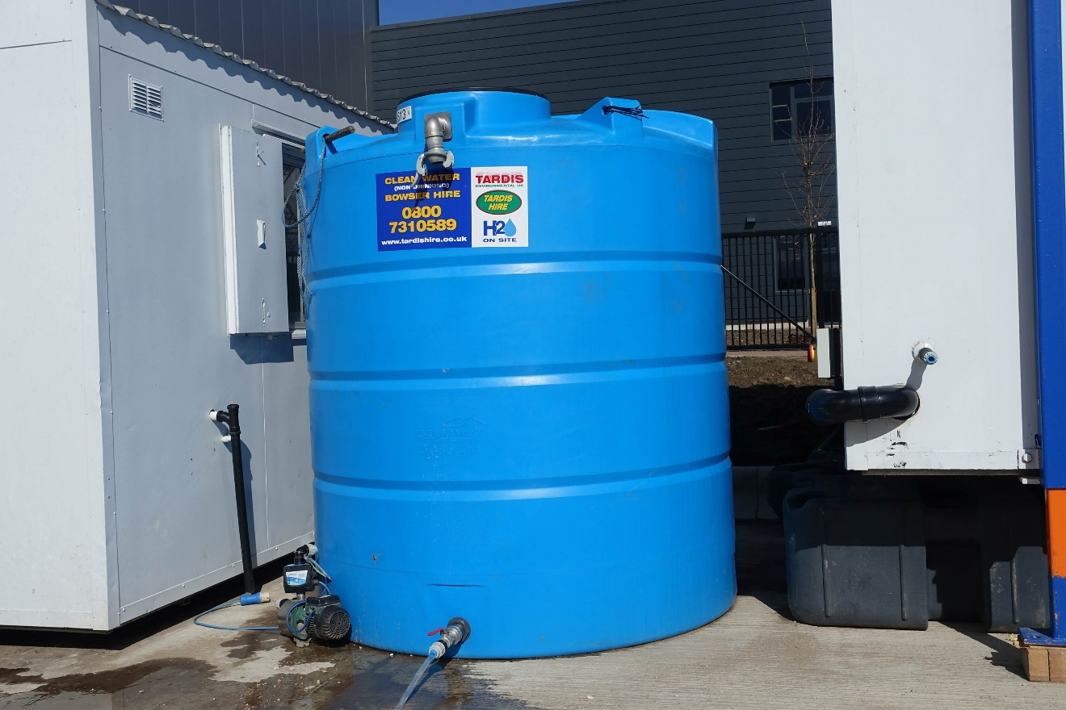

  - IOT-ENABLED WATER MONITORING AND CONTROLLING SYSTEM
  - -An embedded system approach

  - Batch no. B11
  - MOHAMMED MUSHARAF ALI ( 1604-21-735-116 )
  - MD RIYAN ( 1604-21-735-117 )
  - MOHAMMED AFHAAM ISMAIL ( 1604-21-735-102 )
  - GUIDE: Dr. MA Raheem

  - OVERVIEW

- INTRODUCTION

- APPLICATION AREAS OF THE PROJECT

- IDENTIFICATION OF PROBLEM

- OBJECTIVE

- LITERATURE SURVEY

- METHODOLOGY

- BLOCK DIAGRAM

- WORKFLOW

- WORKING

- EXPECTED OUTPUT

- PROJECT TIMING DIAGRAM

- CONCLUSION

- REFERENCES
INTRODUCTION

  - In tall buildings and household residences, water tank management often requires manual intervention, such as turning the motor on and off when the tank is empty or full. This process is inefficient, as it can lead to water overflow, motor overheating, and even malfunction.
  - Our IoT-based solution automates this process with several unique features:
- Wireless communication reduces the cost of wiring, especially in tall buildings.
- Predictive maintenance monitors motor health and increases its lifespan beyond 10 years.
- Provides call/text alerts when issues occur.
- Enables cloud-based monitoring via an application or website.
- Fully automates manual tasks, reducing labor and improving efficiency.
- The device can be integrated with any electronic system for automation, monitoring, and remote access.
- It is particularly effective for tall buildings, malls, and apartments where water overflow and motor malfunctions are frequent.

  - APPLICATION AREAS OF THE PROJECT
- Residential Buildings: Automates water tank management in homes and apartments, preventing overflow and motor damage.
- Commercial Buildings: Useful in malls, offices, and hotels where water usage is high, ensuring efficient water management.
- Industries: Monitors water levels and motor health in factories to prevent downtime and optimize water usage.
- Agricultural Fields: Automates irrigation by managing water pumps and tanks, reducing manual labor.
- Public Infrastructure: Effective in schools, hospitals, and public water supply systems to ensure continuous water availability.
- Smart Cities: Supports the development of smart water management systems for urban areas using IoT technology.
This project is versatile and can be applied wherever automated water monitoring and motor management are essential.

IDENTIFICATION OF PROBLEM
Identification of Problem
In tall buildings, households, and commercial spaces, managing water tanks manually is inefficient and prone to issues:
- Manual Intervention: Users must manually turn the motor on when the tank empties and turn it off when full.
- Water Overflow: Overflow often occurs due to delayed action, leading to water wastage.
- Motor Overheating: Continuous running of motors can cause overheating and potential damage.
- Labor and Monitoring Effort: Manual monitoring requires time and effort, especially in large buildings.
- Lack of Predictive Maintenance: No real-time monitoring exists for motor health, leading to unexpected breakdowns.
- Cost of Wiring: In tall buildings, wiring costs for water tank systems can be high.
To address these problems, an IoT-based automated water monitoring system is required to ensure efficient tank management, reduce manual effort, and prolong motor life.
OBJECTIVE
The main objective of this project is to design and implement an IoT-based automated water monitoring system that:
- Automates Water Tank Management: Eliminates manual intervention in controlling water motors.
- Prevents Water Overflow: Ensures efficient water usage by monitoring tank levels.
- Monitors Motor Health: Implements predictive maintenance to enhance motor lifespan.
- Reduces Wiring Costs: Uses wireless communication for tank and motor control, ideal for tall buildings.
- Provides Alerts: Sends call or text notifications for issues like motor malfunction or water overflow.
- Enables Remote Monitoring: Allows system monitoring and control via cloud-based applications or websites.
This project aims to simplify water management, reduce labor, and improve the reliability of water motors.
LITERATURE SURVEY
Author(s) | Year | Research Resource | Key Findings | Limitations
S. Sharma et al. | 2020 | International Journal of Smart Water Systems | IoT-based water level monitoring using sensors. | Limited focus on motor health and prediction.
A. Kumar, R. Patel | 2021 | IEEE Access Journal | Automated water tank system with wireless communication. | There is no predictive maintenance for motor lifespan.
B. Gupta, M. Reddy | 2022 | Journal of Sustainable Smart Systems | Cloud-based water monitoring with remote alerts. | High implementation cost for large buildings.
C. Li et al. | 2023 | Sensors and Actuators Journal | Real-time monitoring of water tanks using IoT. | No integration with other electronic devices.
D. Singh, P. Roy | 2024 | International Conference on Automation and IoT Systems | Smart water and motor management with text alerts. | Limited scalability for multiple systems.

This survey highlights the evolution of water monitoring systems and the need for integrating predictive maintenance and versatile automation to address current limitations effectively.

METHODOLOGY
The methodology of the IoT-based Water Monitoring System involves the following steps:
- System Design:
  - Selection of hardware components such as water level sensors, motor controllers, IoT modules, and microcontrollers (STM32).
- Wireless Communication:
  - Integration of sensors and motor controllers with wireless modules for communication between the water tank and motor.
- Data Acquisition:
  - Sensors detect water levels in the tank and send data to the microcontroller.
  - Motor health parameters (temperature, vibration) are monitored for predictive maintenance.
- Cloud Integration:
  - Collected data is sent to the cloud server for real-time monitoring through an application or website.
- Automation and Alerts:
  - The system automatically turns the motor ON/OFF based on the water level.
  - Call/text alerts are sent in case of water overflow, motor issues, or system malfunctions.
- Testing and Validation:
  - The system is tested for accuracy, efficiency, and reliability in various scenarios like residential and commercial setups.
This methodology ensures a smart, automated, and predictive solution for effective water tank and motor management.

BLOCK DIAGRAM
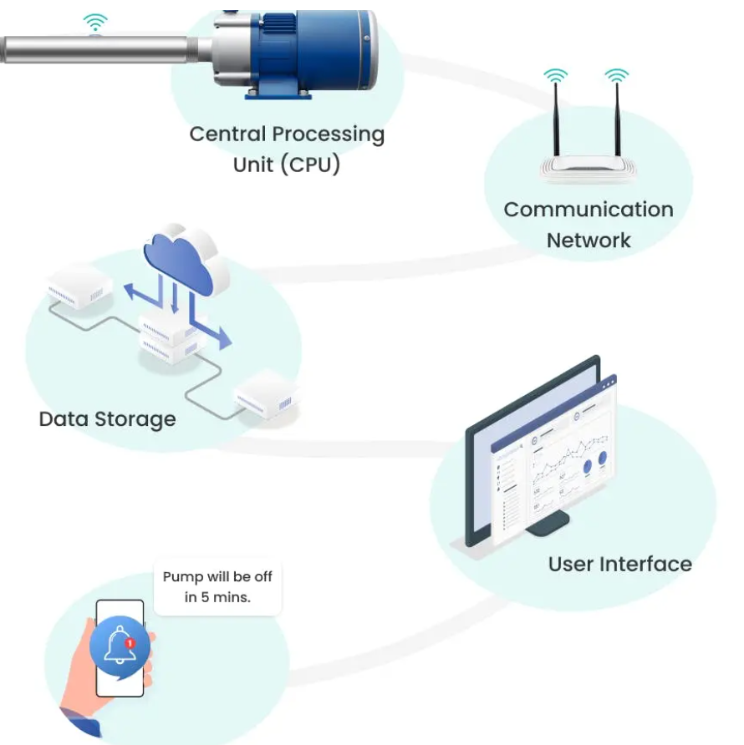
Alert system

WORKFLOW
The IoT-based Water Monitoring System workflow is as follows:
- Initialization:
  - The system initializes sensors, microcontrollers, and wireless communication modules.
- Data Collection:
  - Water level sensors continuously monitor the tank's water level.
  - Motor health parameters like temperature and vibration are recorded.
- Data Processing:
  - The microcontroller processes sensor data and decides whether to turn the motor ON or OFF based on predefined thresholds.
- Wireless Communication:
  - Sensor data and motor status are transmitted wirelessly to a cloud platform for real-time monitoring.
- Automation and Alerts:
  - The motor operates automatically based on water level data.
  - Alerts (call/text) are generated for water overflow, motor malfunction, or abnormal sensor readings.
- Cloud Monitoring:
  - Users can monitor and control the system remotely through a mobile app or web interface.
- Shutdown or Maintenance:
  - The system provides predictive maintenance alerts for the motor to prevent failures.
This seamless workflow ensures efficient water management with minimal manual intervention.

WORKING
The IoT-based Water Monitoring System operates as follows:
- Sensor Monitoring:
  - Water level sensors in the tank measure the current water level.
  - Motor health sensors monitor temperature, vibration, or other parameters.
- Data Transmission:
  - The sensor data is sent to the microcontroller for processing.
  - Wireless communication transmits the processed data to a cloud platform.
- Automation:
  - The system automatically turns the motor ON when the water level is low and OFF when the tank is full.
- Alerts and Notifications:
  - In case of abnormal conditions like motor malfunction, overheating, or water overflow, the system sends call/text alerts.
- Cloud Integration:
  - Users can monitor real-time data and control the motor remotely through a mobile app or website.
- Predictive Maintenance:
  - The system analyzes motor health and provides alerts for maintenance needs to prevent failures.
  - Uses AIML module for the predictive maintenance
This integrated system ensures reliable and efficient water and motor management with real-time monitoring and control.

Expected output
The IoT-based Water Monitoring System is expected to deliver the following outcomes:
- Automated Water Tank Management:
  - Automatic operation of the motor based on water levels, preventing overflow and dry runs.
- Motor Health Monitoring:
  - Real-time tracking of motor temperature and vibration to enhance motor lifespan.
- Wireless Communication:
  - Seamless data transmission between the tank and motor without the need for extensive wiring.
- Real-Time Alerts:
  - Call or text notifications for water overflow, motor issues, or abnormal conditions.
- Remote Monitoring and Control:
  - Ability to monitor and control the system via a cloud-based application or website.
- Energy and Resource Savings:
  - Reduced water wastage and energy consumption through efficient motor usage.
- Predictive maintenance:
- Protect the system from upcoming threats.
The system ensures smarter, more efficient water and motor management for residential and commercial applications.

PROJECT TIMELINE
- Week 1-2: Research and Planning
  - Define project requirements and objectives.
  - Select hardware components and finalize design.
- Week 3-4: Hardware Assembly
  - Assemble sensors, microcontrollers, and IoT modules.
  - Test individual components for functionality.
- Week 5-6: Software Development
  - Develop code for sensor integration, motor control, and wireless communication.
  - Implement cloud connectivity for monitoring and control.
- Week 7: System Integration
  - Combine hardware and software components into a unified system.
  - Apply the AIML module for predictive maintenance
  - Test the complete setup under controlled conditions.
- Week 8: Testing and Debugging
  - Conduct real-world testing in various scenarios (e.g., tall buildings, homes).
  - Debug and optimize system performance.
- Week 9: Deployment and Documentation
  - Deploy the system for practical use.
  - Prepare documentation and reports.
This timeline ensures the project is completed efficiently with time for testing and optimization.

CONCLUSION
The IoT-based Water Monitoring System provides an efficient and automated solution for water and motor management. It eliminates manual intervention, reduces water wastage, and extends motor lifespan through predictive maintenance. The integration of wireless communication and cloud-based monitoring ensures cost-effectiveness and ease of use, making it ideal for residential, commercial, and industrial applications. This project contributes to smarter resource management and offers a scalable, reliable, and sustainable approach to modern water management challenges.
REFERENCES
- Sharma, S., et al. (2020). IoT-based water level monitoring using sensors. International Journal of Smart Water Systems.
- Kumar, A., & Patel, R. (2021). Automated water tank system with wireless communication. IEEE Access Journal.
- Gupta, B., & Reddy, M. (2022). Cloud-based water monitoring with remote alerts. Journal of Sustainable Smart Systems.
- Li, C., et al. (2023). Real-time monitoring of water tanks using IoT. Sensors and Actuators Journal.
- Singh, D., & Roy, P. (2024). Smart water and motor management with text alerts. International Conference on Automation and IoT Systems.
- These references highlight the research and advancements in IoT-based water management systems and underline the importance of automation and predictive maintenance.
